Phase 4 · Extend, Automate & Ship
Exercise 11: Build a Custom Skill
Dev cycle | Build (extend Claude Code)
CC features | Agent Skills (.claude/skills/<name>/SKILL.md), /skill-name invocation, autonomous triggering, /reload-skills
Time | 40 min
You produce | A reusable analytics-endpoint Skill that scaffolds endpoints to your conventions

Objective
Skills are how you teach Claude Code your way of doing things, packaged so they can be invoked by name or triggered automatically when relevant. You will build a Skill that scaffolds a new FastAPI endpoint to ExpenseFlow's exact conventions, so you never re-explain them again.
Walk-through
1 | Create the skill folder and file
Skills live in .claude/skills/<name>/SKILL.md. The frontmatter name becomes the /command; the description is what Claude reads to decide when to trigger it autonomously. Create the file.
Run in terminal
PS> mkdir .claude\skills\analytics-endpoint
Create / paste → .claude/skills/ANAlytics-endpoint/SKILL.md
---
name: analytics-endpoint
description: Scaffold a new FastAPI endpoint for ExpenseFlow to house conventions. Use whenever I ask to add an endpoint, route, or API method.
---

# Add an ExpenseFlow endpoint

When asked to add an endpoint, follow these rules exactly:

1. Put the route in app/routes.py on the existing APIRouter. Do not create new files unless asked.
2. Add a matching pydantic model to app/schemas.py (request and/or response). Amounts are integer minor units.
3. Type hints and a one-line docstring on the handler. Use the get_db dependency for any DB access.
4. Write endpoints (POST/PUT/PATCH/DELETE) MUST depend on require_api_key from app/auth.py. GET endpoints stay open.
5. Validate inputs: reject negative amounts, cap description at 500 chars, restrict status to pending/approved/rejected.
6. Money stays in INR minor units; if a new currency is involved, convert via app/fx.py convert_to_base.
7. After writing, add a pytest test in tests/test_api.py covering the happy path and one failure path.
8. Show me the diff before applying, one file at a time.
VALIDATE The folder .claude/skills/analytics-endpoint/ contains SKILL.md with valid frontmatter (name and description) followed by the instructions.

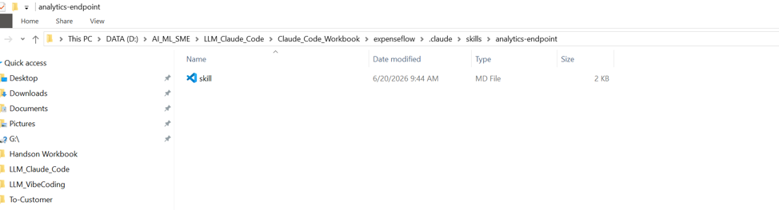

2 | Make Claude Code see it
Reload skills without restarting the session, then confirm the new skill is registered.
Inside the session
PS> /reload-skills
PS> /help
VALIDATE /help (or typing /analy) now shows /analytics-endpoint among available commands. If not, check the folder path uses backslashes and the SKILL.md frontmatter is valid YAML.
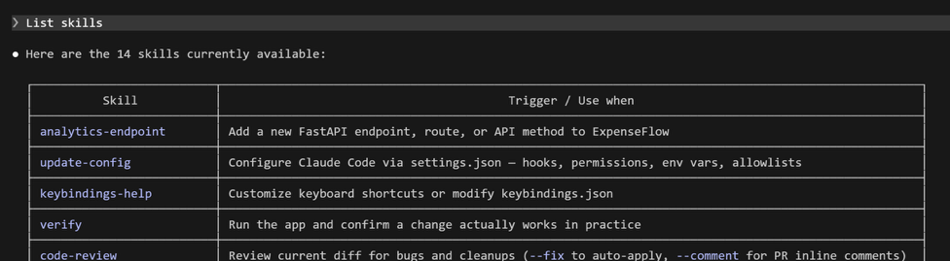
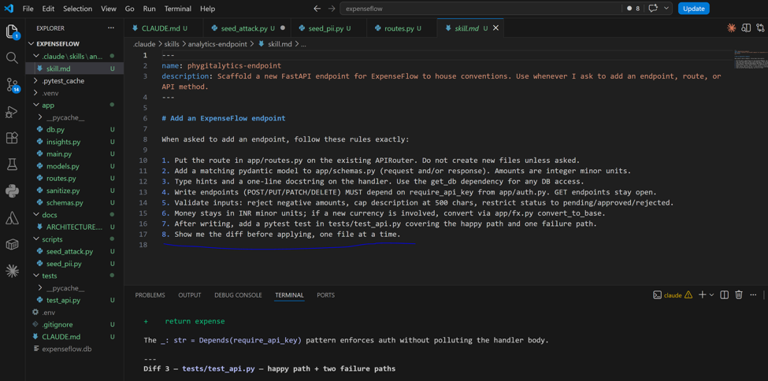

3 | Invoke the skill explicitly
Call it by name to add a real endpoint. Because the skill encodes your conventions, the prompt can be short.
Type this prompt into Claude Code
/analytics-endpoint add an endpoint to update an expense's category (PATCH /expenses/{id}/category) that takes a new category and returns the updated expense.
VALIDATE Claude follows the skill: it edits routes.py and schemas.py, attaches require_api_key (it is a write), validates input, and adds a pytest test, all shown as diffs first. Compare its behaviour to a plain prompt: it did not need re-telling any convention.
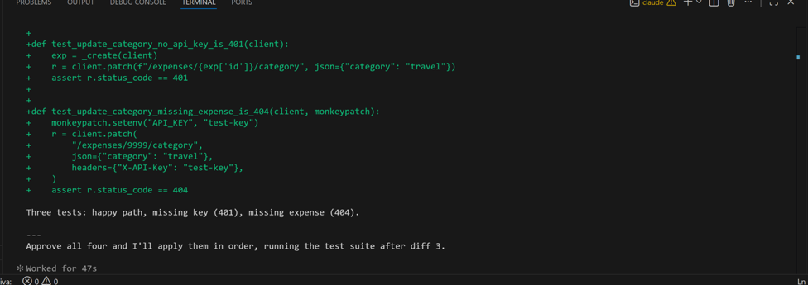
4 | Watch it trigger autonomously
The real power of a Skill is automatic invocation. Ask for an endpoint in plain English, without naming the skill, and confirm Claude applies the same rules anyway because the description matched.
Type this prompt into Claude Code
Add a GET endpoint that returns total approved spend grouped by category.
VALIDATE Even without /analytics-endpoint, Claude applies the skill's conventions (get_db, GET stays open, a test is added). The description line is what made it trigger: that is why skill descriptions matter.

5 | Run the new tests
Confirm the skill-generated endpoints come with passing tests.
Run in terminal
PS> python -m pytest -q
VALIDATE The suite still passes, now including tests for the two endpoints the skill produced. Your conventions are now executable and self-checking.
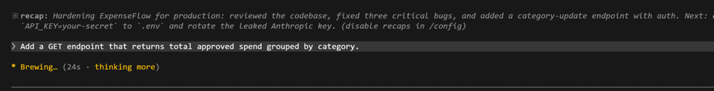

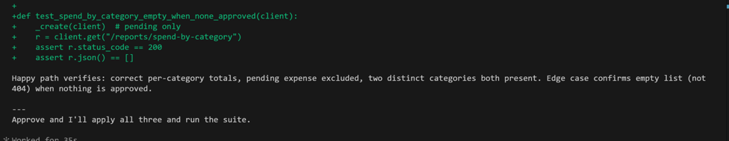

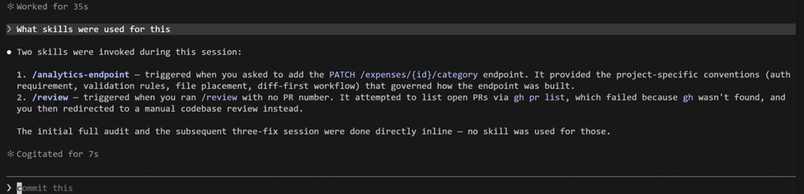

What success looks like
- A working Skill lives in .claude/skills/ and appears as a slash command.
- You triggered it both explicitly (by name) and autonomously (by matching its description).
- Endpoints produced through the skill arrived pre-tested and on-convention with no re-explaining.
Common pitfalls (Windows and macOS)
- Frontmatter must be valid YAML between two --- lines. A stray tab or missing colon stops the skill loading silently.
- The description is the trigger. Vague descriptions mean Claude never auto-invokes; specific ones (the kinds of requests it covers) trigger reliably.
- After a long session, skills get re-attached on compaction but only the most recent invocation. If behaviour fades, re-invoke.
Stretch goal
Turn your REVIEW.md from Exercise 10 into a second skill, .claude/skills/review-expenseflow/SKILL.md, so /review-expenseflow runs your house review standard on demand. You are now building a personal toolkit on top of Claude Code.

